**DD Creator Tutorial**

1. Visit the following URL: <https://doomlab.shinyapps.io/ddcreator/>. The main page should look like this:

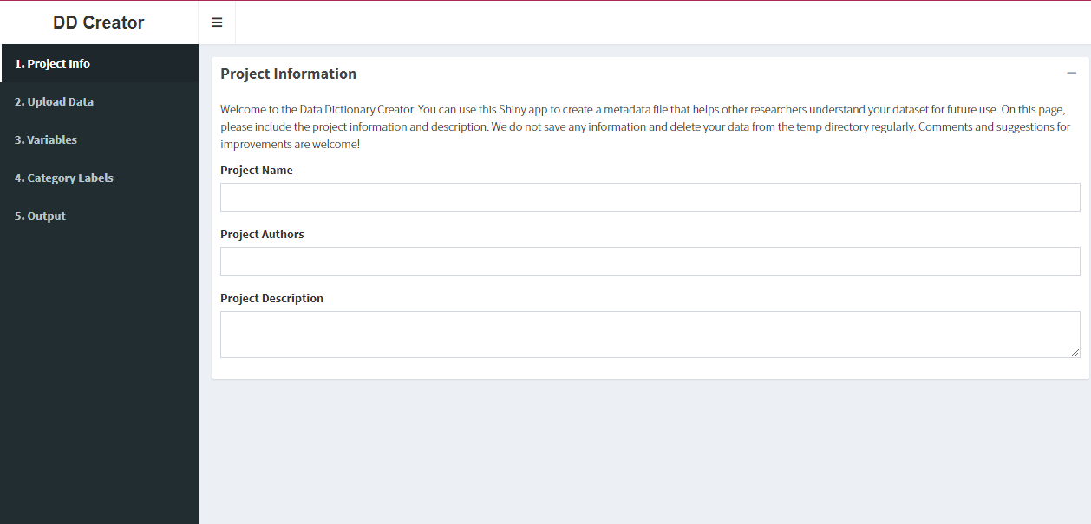

1. Type in the appropriate information under the Project Name, Project Authors, and Project Description fields on the first page (Project Information). These are shown in the picture above.
2. Click on the Upload Data tab on the left-hand side of the page. The page is shown below:

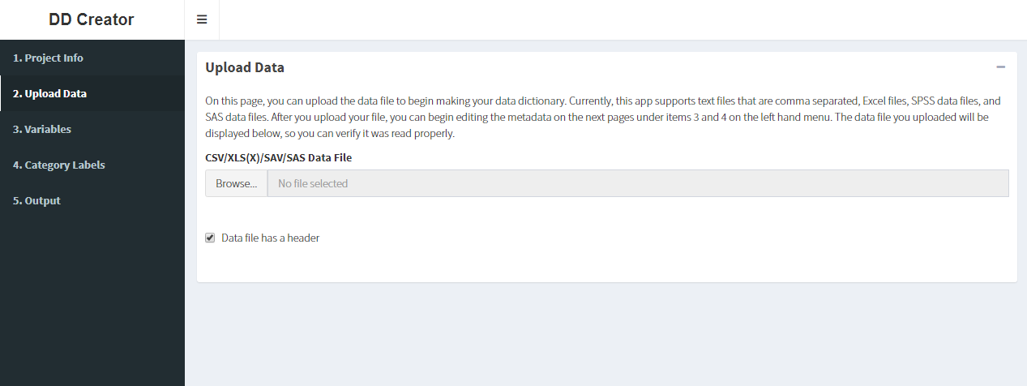

1. Read the page description so you know what file to use and click Browse (shown in the picture above) and select the data file from your computer. (Note: There is a box next to “Data file has a header” that you can either select or deselect before or after you upload the data.) The information will generate on the screen, and you will be able to change the number of entries you see on the screen as well as use a search bar to find specific information in the data. If you scroll to the bottom of the page, you will be able to move between pages by using the arrows on the bottom-left-hand side.
2. Click on the Variables tab on the left-hand side of the page. The page is shown below (Note: the data that you uploaded in the previous step will be shown under the information that you see here):

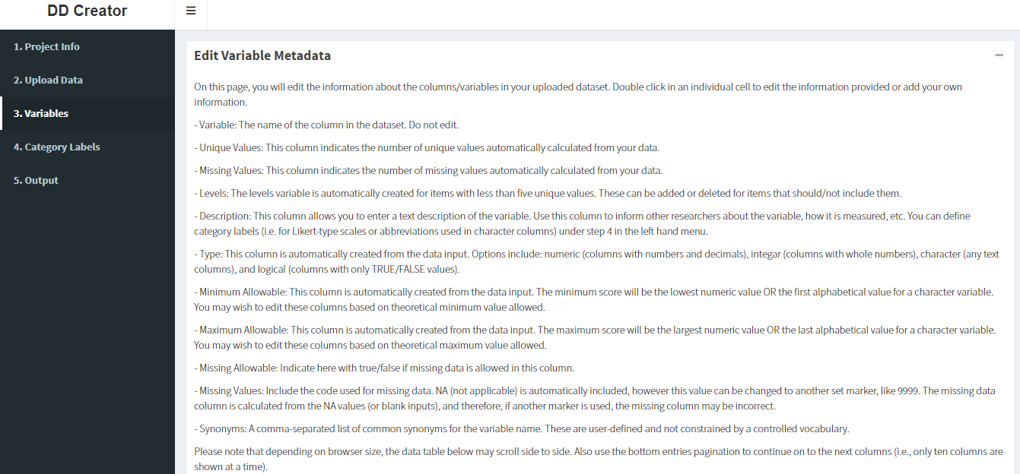

1. Follow the instructions on the page to edit the data you uploaded. Any changes you make will save automatically.
2. Click on the Category Labels tab on the left-hand side of the page. The page is shown below (Note: what you see in the drop-down box under Columns will vary depending on your data):

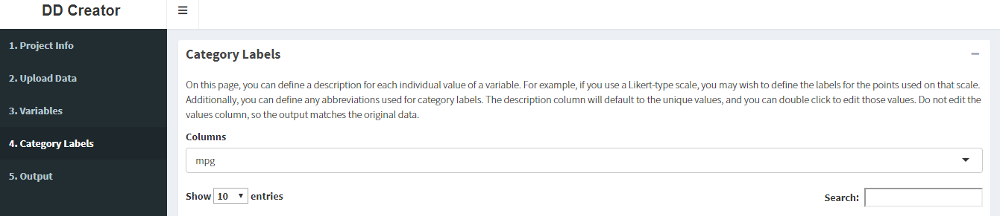

1. Read the instructions and use the drop-down box under Columns to choose which description you wish to change. Double-click on the individual cells to make changes. The page will save automatically.
2. Click on the Output tab on the left-hand side of the page. The page is shown below:

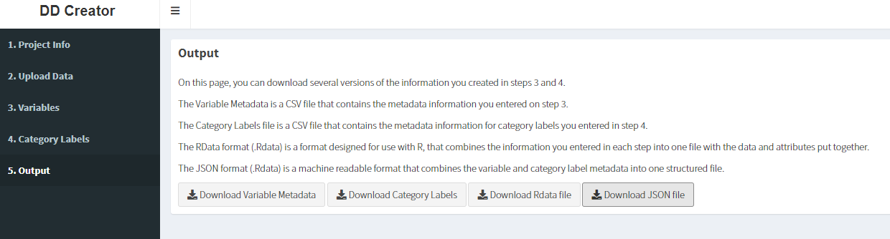

1. Read the instructions and click on the files that you wish to download to your computer.